Freaky Friday Feedback

«Hvorfor Virtual Reality?» skal gå til ein side. Der trenger det bare vere header, litt tekst og nokon bilder, du kan bestemme kva du liker best.

Great work! The looks almost perfect from what I imagined it would be. There are only a few changes I would like you to make. «Hvorfor Virtual Reality?» should go to a site. The site needs a header and a little bit more text that argues why we use VR for our project.

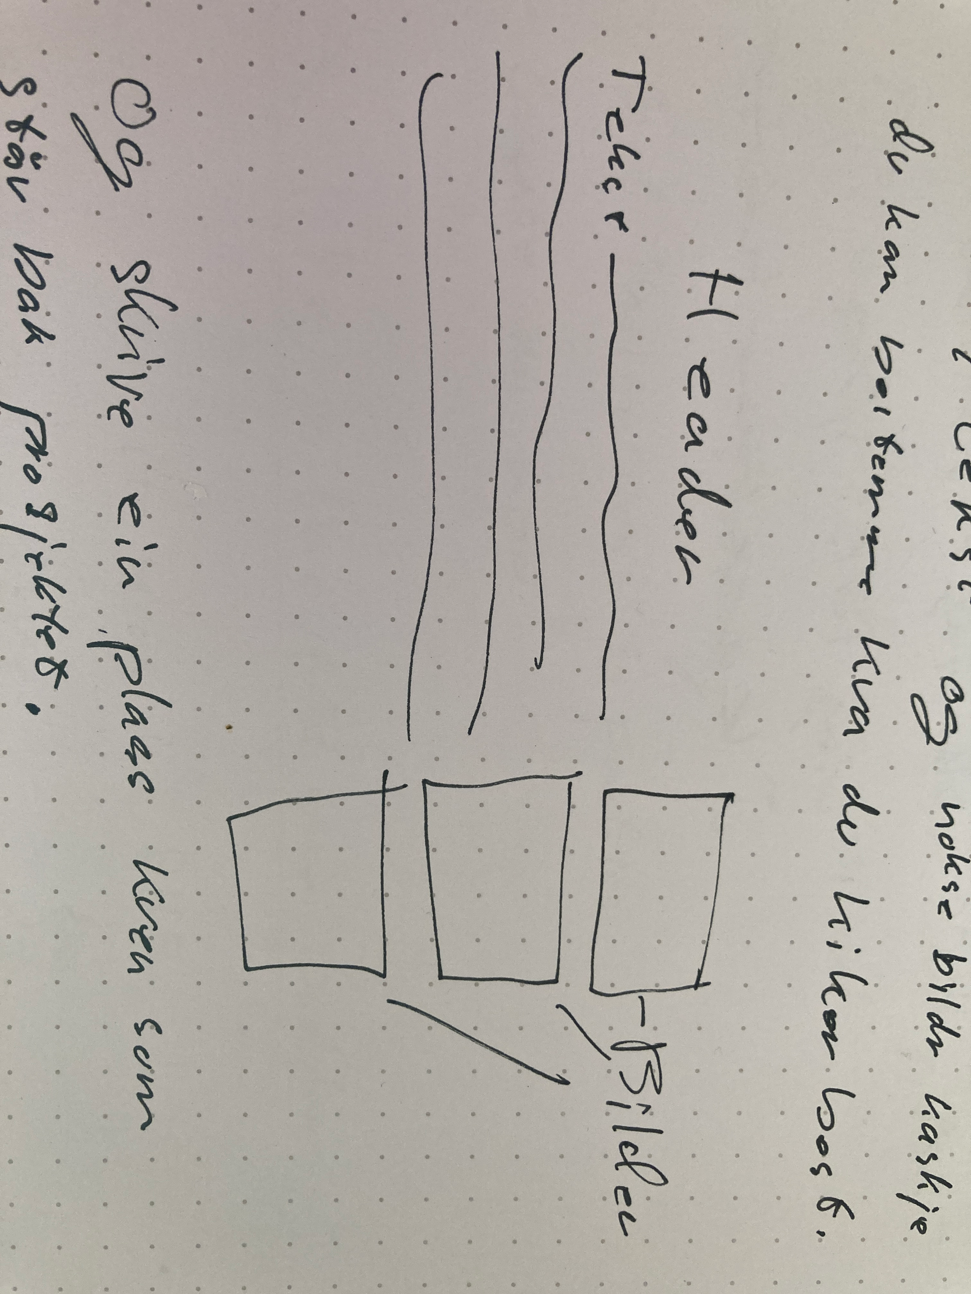

The front page should also show whom is behind the project and the site. You can write it in the box where “Nettside laget av Eirik Skavdal” is or decide another place for it.

An example of what the “Hvorfor Virtual Reality?” site:

One last thing. Make the nav bar non-transparent. Good work Eirik!